21

THE THEORY OF CONSUMER CHOICE

WHAT’S NEW IN THE SEVENTH EDITION:

There are no major changes to this chapter.

LEARNING OBJECTIVES:

By the end of this chapter, students should understand:

➢ how a budget constraint represents the choices a consumer can afford.

➢ how indifference curves can be used to represent a consumer’s preferences.

➢ how a consumer’s optimal choices are determined.

➢ how a consumer responds to changes in income and changes in prices.

➢ how to decompose the impact of a price change into an income effect and a substitution effect.

➢ how to apply the theory of consumer choice to three questions about household behavior.

CONTEXT AND PURPOSE:

Chapter 21 is the first of two unrelated chapters that introduce students to advanced topics in microeconomics. These two chapters are intended to whet their appetites for further study in economics. Chapter 21 is devoted to an advanced topic known as the theory of consumer choice.
The purpose of Chapter 21 is to develop the theory that describes how consumers make decisions about what to buy. So far, these decisions have been summarized with the demand curve. The theory of consumer choice underlies the demand curve. After developing the theory, the theory is applied to a number of questions about how the economy works.

KEY POINTS:

• A consumer’s budget constraint shows the possible combinations of different goods she can buy given her income and the prices of the goods. The slope of the budget constraint equals the relative price of the goods.

• The consumer’s indifference curves represent her preferences. An indifference curve shows the various bundles of goods that make the consumer equally happy. Points on higher indifference curves are preferred to points on lower indifference curves. The slope of an indifference curve at any point is the consumer's marginal rate of substitution—the rate at which the consumer is willing to trade one good for the other.

• The consumer optimizes by choosing the point on her budget constraint that lies on the highest indifference curve. At this point, the slope of the indifference curve (the marginal rate of substitution between the goods) equals the slope of the budget constraint (the relative price of the goods), and the consumer's valuation of the two goods (measured by the marginal rate of substitution) equals the market's valuation (measured by the relative price).

• When the price of a good falls, the impact on the consumer’s choices can be broken down into an income effect and a substitution effect. The income effect is the change in consumption that arises because a lower price makes the consumer better off. The substitution effect is the change in consumption that arises because a price change encourages greater consumption of the good that has become relatively cheaper. The income effect is reflected in the movement from a lower to a higher indifference curve, whereas the substitution effect is reflected by a movement along an indifference curve to a point with a different slope.

• The theory of consumer choice can be applied in many situations. It explains why demand curves can potentially slope upward, why higher wages could either increase or decrease the quantity of labor supplied, and why higher interest rates could either increase or decrease saving.

CHAPTER OUTLINE:

This chapter is an advanced treatment of consumer choice using indifference curve analysis. This chapter is much more difficult than the other chapters in the text. Most undergraduate principles students will find this material challenging.

I. The Budget Constraint: What the Consumer Can Afford
The best way to develop this model is to use specific examples with definite quantities, prices, and levels of income.

A. Example: A consumer has an income of $1,000 per month to spend on pizza and Pepsi. The price of a pizza is $10 and the price of a liter of Pepsi is $2.

B. If the consumer spends all of her income on pizza, she can buy 100 pizzas per month. If the consumer spends all of her income on Pepsi, she can buy 500 liters per month.

C. Definition of budget constraint: the limit on the consumption bundles that a consumer can afford.

D. Using this information, we can draw the consumer's budget constraint.

a. The slope of the budget constraint measures the rate at which the consumer can trade one good for another.

b. The slope of the budget constraint equals the relative price of the two goods (1 pizza can be traded for 5 liters of Pepsi).
Figure 1

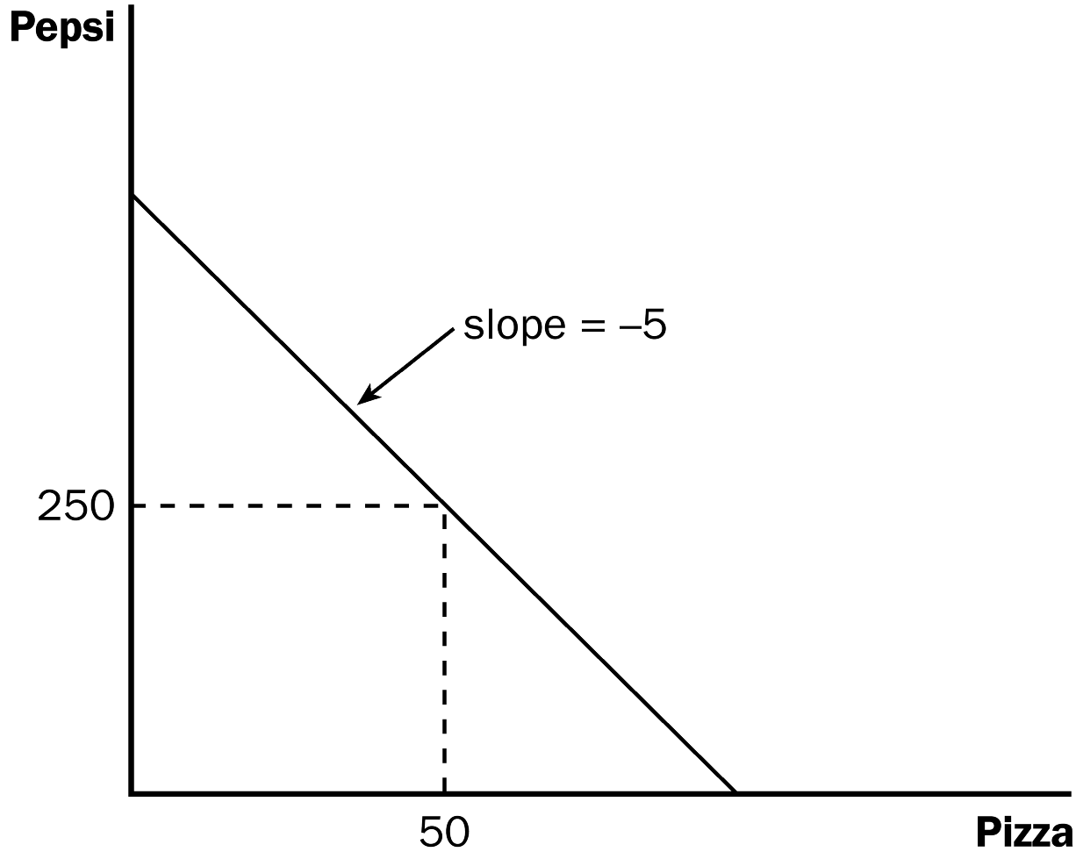
Although the book does it later, now might be a good time to show the effects of price and income changes. Show mathematically and graphically how a doubling (or halving) of the price of one good will cause its intercept to change. Also show what happens to the vertical and horizontal intercepts when income changes. Emphasize that the budget depicts the consumption possibilities available to the individual. The consumer can be on or within the budget constraint, but not beyond it.

Activity 1—You Can’t Always Get What You Want

Type: In-class activity
Topics: Budget constraints
Materials needed: None
Time: 5 minutes
Class limitations: Works in any size class

Purpose
This activity shows consumers are restricted by their limited incomes and by the prices of goods.

Instructions
Ask the students to think about maximizing their own utility.

Specifically, ask them to assume that billionaire Bill Gates offers to buy them the one thing that would increase their happiness by the greatest amount. It cannot be money or a financial instrument, but he will buy them any single thing they feel would make them happy. Have them write down their requested item.

Ask a few students what they chose. Then ask the class, “Why don’t you buy that item for yourself? Isn’t it the one thing that will increase your happiness by the largest amount? Why not buy it today?”

The answer, of course, is they cannot afford it. Consumers’ purchases are constrained by their incomes.

However, that is not the only constraint. Ask them to estimate the cost of their selected items and write it next to the items. Now, have them assume Bill Gates is too busy to go shopping, so he gives them the money instead. He does not put any restrictions on the use of the cash; all he wants is to see them maximize their happiness.

This eliminates the income barrier. Ask the class how many of them would spend the entire amount of money buying that single good.

Some students would buy that item, but most would buy a variety of things. Using the money for a single expensive item may not be the best way to allocate their newfound wealth. Buying several cheap things may give a higher level of happiness.

Points for Discussion
1) Consumers have limited income.
2) Goods have prices.

Together these things determine the consumer’s budget constraint.

II. Preferences: What the Consumer Wants

A. Representing Preferences with Indifference Curves

1. A consumer is indifferent between two bundles of goods and services if the two bundles suit her tastes equally well.

2. Definition of indifference curve: a curve that shows consumption bundles that give the consumer the same level of satisfaction.

3. The consumer is indifferent among points A, B, and C.

4. Definition of marginal rate of substitution: the rate at which a consumer is willing to trade one good for another.

5. The marginal rate of substitution is equal to the slope of the indifference curve at any point.

a. Because these indifference curves are not straight lines, the marginal rate of substitution is not the same at all points on a given indifference curve.

b. The rate at which a consumer is willing to trade one good for the other depends on how much of each good she is already consuming.
Figure 2

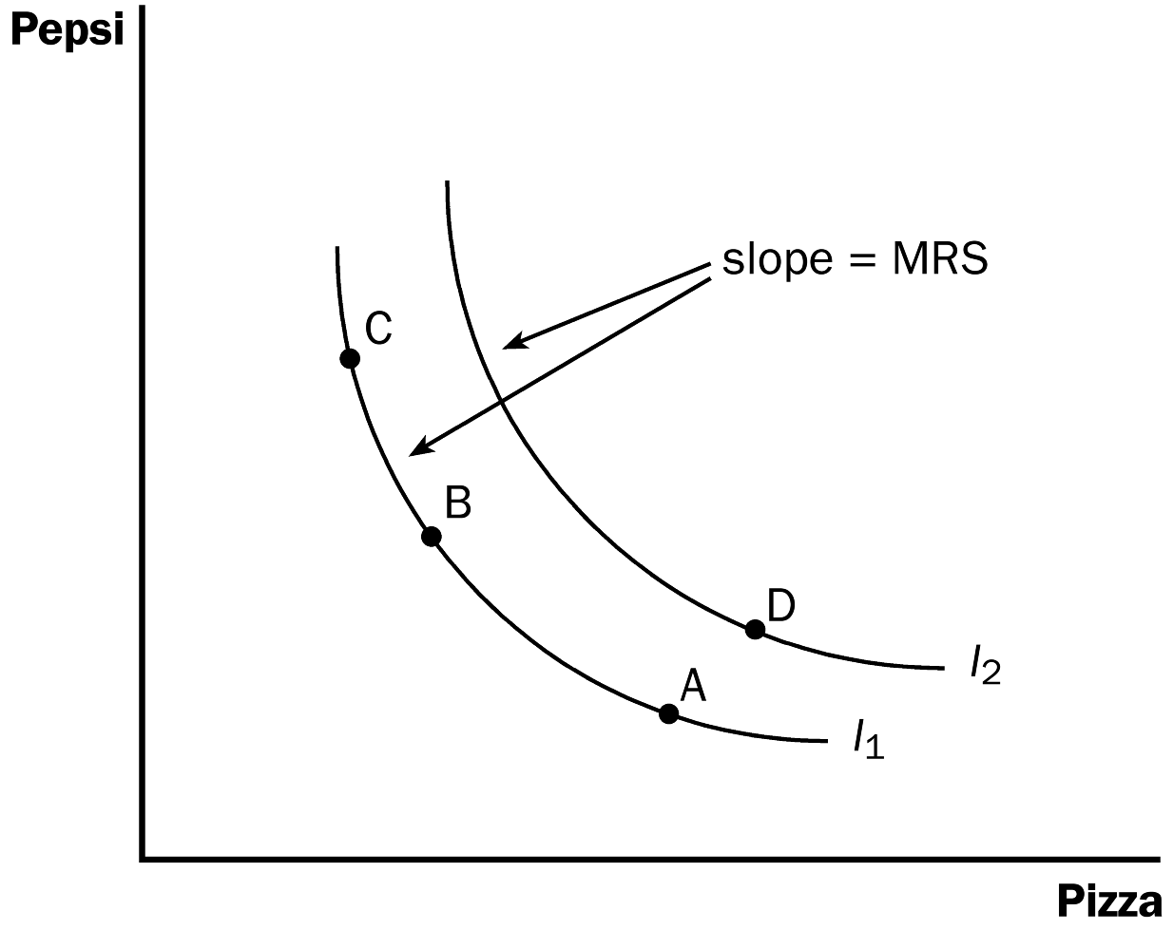

6. A consumer’s set of indifference curves gives a complete ranking of the consumer’s preferences.

7. Any point on indifference curve I₂ will be preferred to any point on indifference curve I₁.

a. It is obvious that point D would be preferred to point A because point D contains more pizza and more Pepsi.

b. We can tell, though, that point D is also preferred to point C because point D is on a higher indifference curve.

B. Four Properties of Indifference Curves

1. Higher indifference curves are preferred to lower ones.

2. Indifference curves are downward sloping.

a. In most cases, the consumer would like more of both goods.

b. If the quantity of one good increases, the quantity of the other good must fall in order for the consumer to remain equally satisfied.

3. Indifference curves do not cross.

a. The easiest way to prove this is by showing what would happen if they did cross.

b. Because point A is on the same indifference curve as point B, the two bundles make the consumer equally happy.
Figure 3

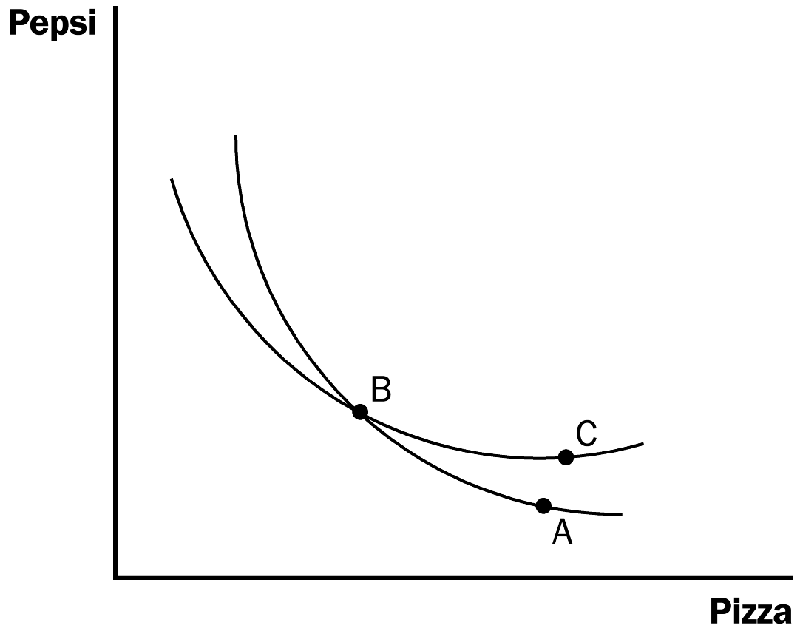

c. Because point C is on the same indifference curve as point B, the two bundles make the consumer equally happy.

d. But this should imply that points A and C make the consumer equally happy, even though point C represents a bundle with more of both goods (which makes it preferred to point A).

4. Indifference curves are bowed inward.
Figure 4

a. The slope of the indifference curve is the rate at which the consumer is willing to trade one good for another.

b. Because people are more willing to trade away goods that they have in abundance and less willing to trade away goods of which they have little, the marginal rate of substitution falls as the consumer gains pizza and loses Pepsi.

C. Two Extreme Examples of Indifference Curves
Figure 5

1. Perfect Substitutes

a. Examples: bundles of nickels and dimes.

b. Most likely, a consumer would always be willing to trade one dime for two nickels, regardless of how many dimes or nickels she has.

c. Definition of perfect substitutes: two goods with straight-line indifference curves.

d. Because the marginal rate of substitution is the same no matter how many dimes and nickels the consumer has, the slope of the indifference curve is constant. Thus, the indifference curve is a straight line.

2. Perfect Complements

a. Example: right shoes and left shoes.

b. Most likely, the consumer would only care about the number of pairs of shoes.

c. Thus, a bundle with five right shoes and five left shoes makes a consumer equally as happy as a bundle with seven right shoes and five left shoes.

d. Definition of perfect complements: two goods with right-angle indifference curves.

III. Optimization: What the Consumer Chooses

A. The Consumer's Optimal Choices

1. The consumer would like to end up on the highest possible indifference curve, but she must also stay within her budget.

2. The highest indifference curve the consumer can reach is the one that just barely touches the budget constraint. The point where they touch is called the optimum.

3. The optimum point represents the best combination of Pepsi and pizza available to the consumer.

a. The consumer would prefer point A, but she cannot afford that bundle because it lies outside of her budget constraint.

b. The consumer could afford bundle B, but it lies on a lower indifference curve and therefore provides less satisfaction.
Figure 6

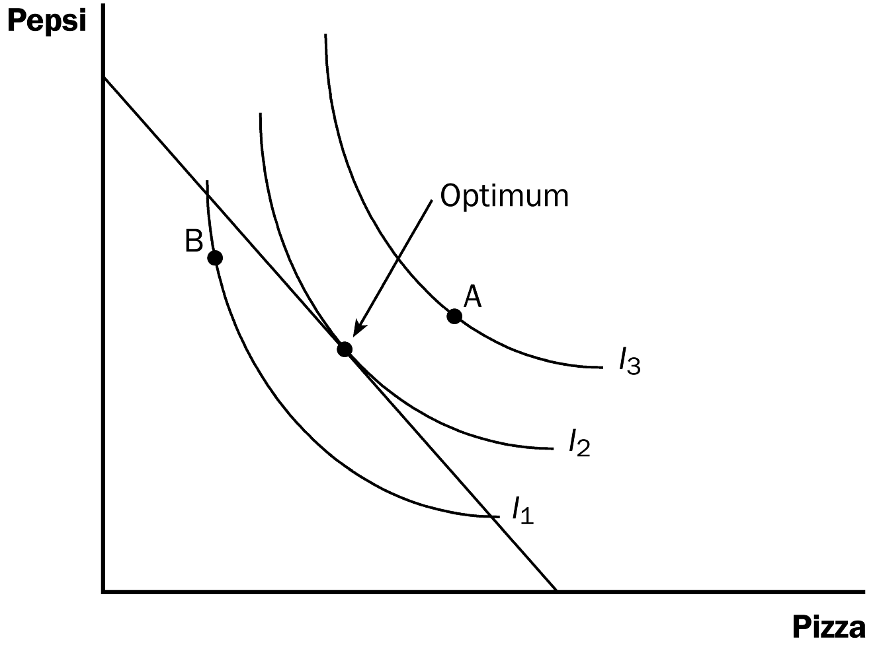
4. At the optimum, the slope of the budget constraint is equal to the slope of the indifference curve.

a. The indifference curve is tangent to the budget constraint at this point.

b. At this point, the marginal rate of substitution is equal to the relative price of the two goods.

c. The relative price is the rate at which the market is willing to trade one good for the other, while the marginal rate of substitution is the rate at which the consumer is willing to trade one good for the other.

B. FYI: Utility: An Alternative Way to Describe Preferences and Optimization

1. Utility is an abstract measure of the satisfaction that a consumer receives from a bundle of goods and services.

2. A consumer will prefer bundle A to bundle B if bundle A provides more utility.

3. Indifference curves and utility are related.

a. Bundles of goods in higher indifference curves provide a higher level of utility.

b. Bundles of goods on the same indifference curve all provide the same level of utility.

c. The slope of the indifference curve reflects the marginal utility of one good compared to the marginal utility of the other good.

4. A consumer can maximize her utility if she ends up on the highest indifference curve possible.

a. This occurs when MRS = P_{X} /P_{Y}.

b. Because MRS = MU_{X} /MU_{Y}, optimization occurs where MU_{X} /MU_{Y} = P_{X} /P_{Y}.

c. This can be rewritten as MU_{X} /P_{X} = MU_{Y} /P_{Y}.

d. This implies that, at the consumer’s optimum, the marginal utility per dollar spent on good X equals the marginal utility per dollar spent on good Y.

C. How Changes in Income Affect the Consumer's Choices
Figure 7

1. A change in income shifts the budget constraint.

a. An increase in income can be shown by an outward shift of the budget constraint; a decrease in income means that the budget constraint shifts inward.

b. Because the relative price of the two goods has not changed, the slope of the budget constraint remains the same.

2. An increase in income means that the consumer can now reach a higher indifference curve.

3. Because the consumer increased her consumption of both goods when her income increased, both Pepsi and pizza must be normal goods.

a. Definition of normal good: a good for which an increase in income raises the quantity demanded.

b. Definition of inferior good: a good for which an increase in income reduces the quantity demanded.
Figure 8

D. How Changes in Prices Affect the Consumer's Choices

1. If the price of only one good changes, the budget constraint will have a different slope.
Figure 9

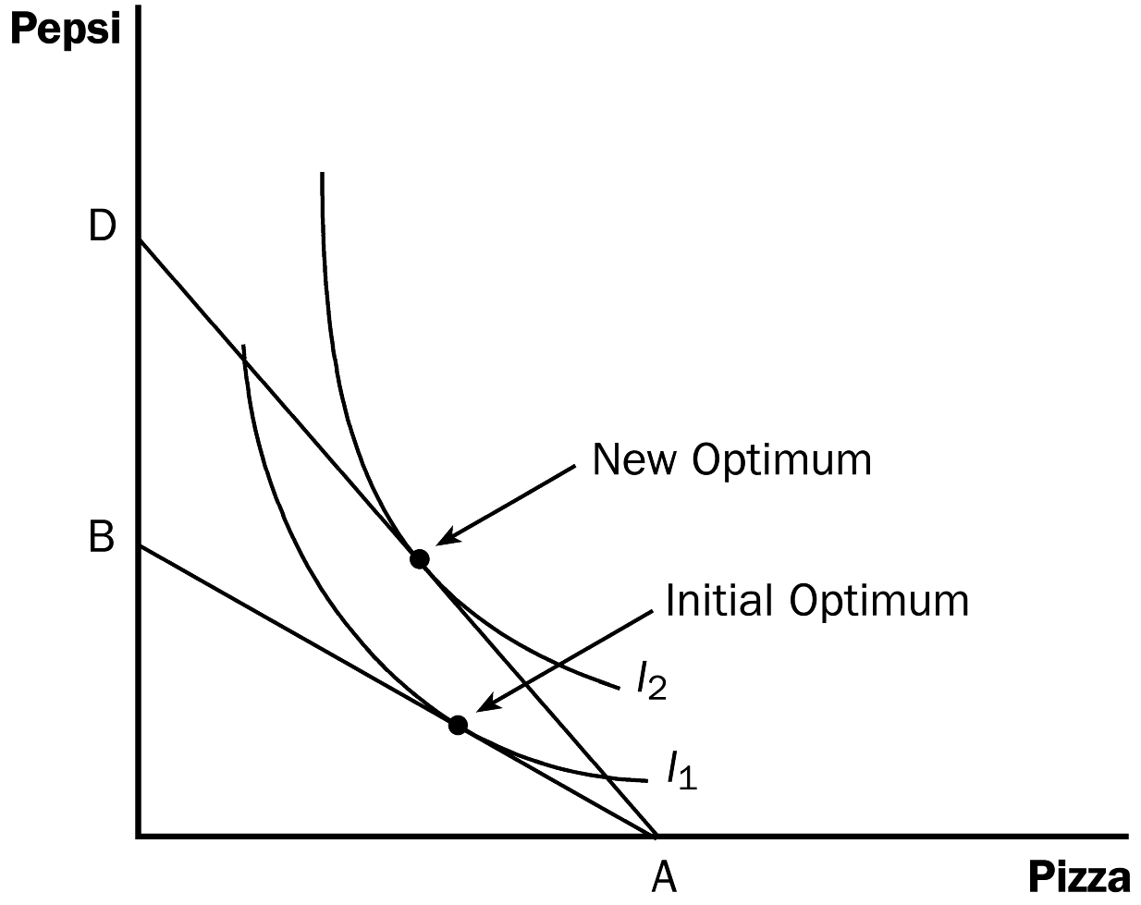

2. Suppose that the price of Pepsi falls from $2 per liter to $1.

a. If the consumer spends her entire income on pizza, the change in the price of Pepsi will not affect her ability to buy pizza, so point A on the budget constraint remains the same.

b. If the consumer spends her entire income on Pepsi, she will now be able to buy 1,000 liters instead of only 500. Thus, the end point of his budget constraint moves from point B to point D.

c. The slope of the budget constraint changes as well. Because the price of Pepsi has fallen, the relative price of the two goods has changed. The consumer can now trade a pizza for 10 liters of Pepsi instead of 5. Therefore, the budget constraint has become steeper.

3. How such a change in the price of one good alters the consumption of both goods depends on the consumer's preferences.

E. Income and Substitution Effects

1. Definition of income effect: the change in consumption that results when a price change moves the consumer to a higher or lower indifference curve.

2. Definition of substitution effect: the change in consumption that results when a price change moves the consumer along a given indifference curve to a point with a new marginal rate of substitution.

3. Suppose that the price of Pepsi falls.
Table 1

a. The decrease in the price of Pepsi will make the consumer better off. Thus, if pizza and Pepsi are both normal goods, the consumer will want to spread this improvement in her purchasing power over both goods. This is the income effect and will make the consumer want to buy more of both goods.

b. At the same time, the consumption of Pepsi has become less expensive relative to the consumption of pizza. This is the substitution effect and it will tend to make the consumer want to purchase more Pepsi and less pizza.

c. The end result must mean that the consumer purchases more Pepsi because both effects move the consumer in that direction. But it is ambiguous whether the consumer buys more pizza, because the income and substitution effects move in opposite directions.
Figure 10

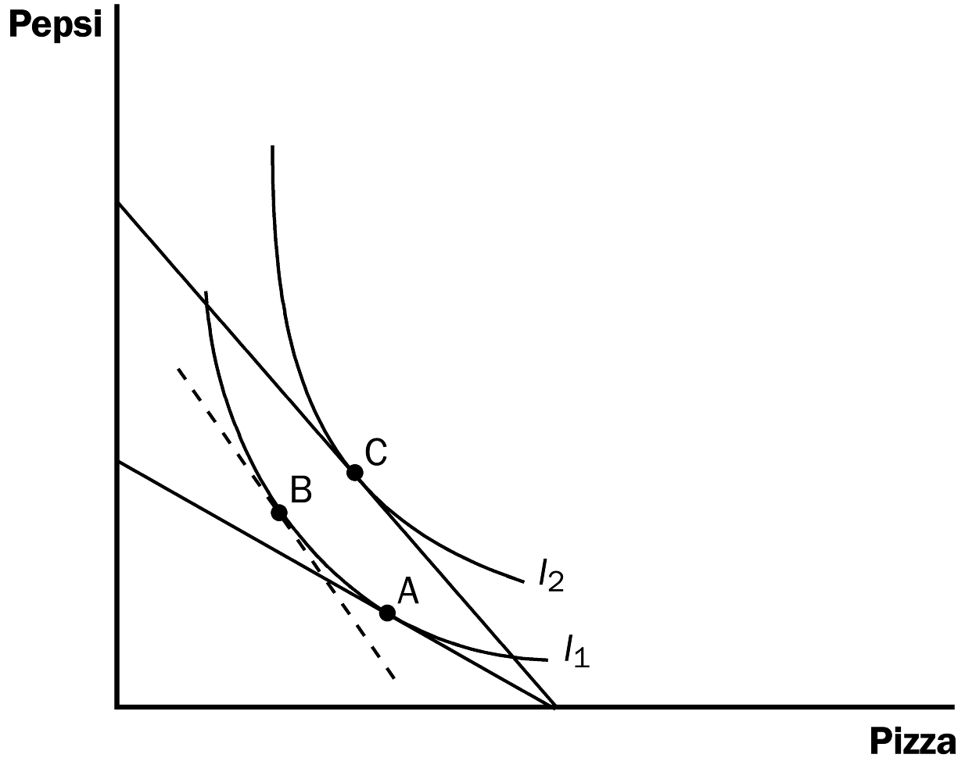

4. We can graphically decompose the change in the consumer's decision into the income effect and the substitution effect.
Students can learn to separate the substitution effects easily if they follow a simple rule: Have them draw a line tangent to the original indifference curve but parallel to the new budget constraint. Make sure that they realize that the substitution effect is seen as the movement along one indifference curve (due to changes in relative prices), and the income effect is seen as the movement from one budget constraint to a parallel budget constraint (because the individual’s purchasing power has changed).
a. First, the consumer moves from the initial optimum (point A) to point B. The consumer is equally happy at either of these points, but the marginal rate of substitution at point B reflects the new relative prices of the two goods.

b. Second, the consumer shifts to higher indifference curve I₂ by moving from point B to C. At these two points, the marginal rate of substitution is the same because the slope of indifference curve I₁ at point B is equal to the slope of indifference curve I₂ at point C.

c. The movement from point A to point B is the substitution effect; the movement from point B to point C is the income effect.

F. Deriving the Demand Curve

Figure 11

1. A demand curve shows how the price of a good affects the quantity demanded.

2. We can view a consumer's demand curve as a summary of the optimal decisions that arise from her budget constraint and indifference curves.

3. When the price of Pepsi falls from $2 per liter to $1, the consumer's budget constraint shifts outward, leading to both an income effect and a substitution effect. The consumer moves from point A to point B, increasing her consumption of Pepsi from 50 liters to 150.

4. Note that at a price of $2, the consumer's quantity of Pepsi demanded is 50. At a price of $1, quantity demanded is 150. These are two of the points on her demand curve for Pepsi.

IV. Three Applications

A. Do All Demand Curves Slope Downward?

Figure 12

1. The law of demand states that when the price of a good rises, people buy less of it.

2. However, it is possible that when the price of a good rises, people actually buy more of it.

3. Example: A consumer spends his entire budget on meat and potatoes. The price of potatoes rises.

a. The budget constraint will shift in.

b. The substitution effect suggests that the consumer will choose more meat and fewer potatoes.

c. The income effect suggests that the individual has suffered a decline in purchasing power and therefore will choose to decrease her consumption of normal goods and increase her consumption of inferior goods.

d. Suppose that potatoes are an inferior good. When the price of potatoes rises, the substitution effect says that the consumer should consume fewer potatoes, while the income effect suggests that she will consume more potatoes. If the income effect dominates, the consumer will end up consuming more potatoes even though the price of potatoes rose.

4. Definition of Giffen good: a good for which an increase in the price raises the quantity demanded.

5. Case Study: The Search for Giffen Goods

a. A recent study by two economists has produced evidence of Giffen goods.

b. Poor households exhibited Giffen behavior by purchasing less rice (a staple) when its price fell and more when its price rose.

B. How Do Wages Affect Labor Supply?
Figure 13

1. Example: Carrie has 100 hours per week that she can devote to working or enjoying leisure. Her hourly wage is $50, which she spends on consumption goods.

2. We can show Carrie's budget constraint graphically.

a. On the horizontal axis, we have hours of leisure. On the vertical axis, we have consumption goods.

b. If Carrie spends all of her time in leisure (100 hours), she will have no consumption. If she spends all of her time working, she will have no leisure but will have consumption of $5,000.

3. Carrie's optimum will occur where the highest possible indifference curve is tangent to the budget constraint.

4. If Carrie's wage increases, her budget constraint will shift outward.

a. The budget constraint will become steeper, because Carrie can get more consumption for every hour of leisure that she gives up.

b. We would expect that consumption would rise, because both of the income and substitution effects move in that direction. When the wage rises, leisure becomes relatively more expensive. Thus, Carrie will increase consumption and decrease leisure. Also when Carrie's wage rises, her purchasing power is increased. Because consumption is a normal good, Carrie will want more consumption.

c. The response of leisure to the change in Carrie's wage is not as straightforward. This occurs because the income and substitution effects with regard to leisure move in opposite directions. When the wage rises, leisure becomes relatively more expensive. Therefore, Carrie will want to consume less leisure. However, when Carrie's wage rises, her purchasing power is increased, causing her to increase her desire for more leisure (because it is a normal good). The end result depends on which effect is dominant.
Figure 14

d. If the substitution effect is greater than the income effect, Carrie will decrease leisure and work more hours if her wage rises. This results in an upward-sloping labor supply curve.

e. If the income effect is greater than the substitution effect, Carrie will increase leisure and work fewer hours if her wage rises. This results in a backward-bending labor supply curve.

5. Case Study: Income Effects on Labor Supply: Historical Trends, Lottery Winners, and the Carnegie Conjecture

a. One hundred years ago, workers worked six days a week. As wages (adjusted for inflation) have risen, the length of the workweek has fallen. This suggests that a backward-bending labor supply curve is not unrealistic.

b. The income effect can be isolated by examining the effects of winning the lottery on an individual's labor supply. Studies have shown that lottery prizes lead to significant decreases in labor supply. This is why Andrew Carnegie gave away much of his wealth before he died rather than leaving it for his children. He worried that such wealth would lead his children to become unproductive.

C. How Do Interest Rates Affect Household Saving?
Figure 15

1. Example: Saul is planning ahead for retirement. There are two time periods. Currently, Saul is young and working and able to earn a total income of $100,000. In the next period, Saul is old and retired. He will have to consume using funds he saved while young. Assume that the interest rate is 10 percent.

2. We can view "consumption while young" and "consumption while old" as the two goods that Saul must choose between.

3. The interest rate determines the relative price of these two goods. For every dollar that Saul saves while he is young, he can consume $1.10 when he is old.

4. We can draw Saul's budget constraint.

a. On the horizontal axis, we have "consumption when young" and on the vertical axis, we have "consumption while old."

b. If Saul saves nothing, he will consume $100,000 when he is young and zero when he is old. Likewise, if he consumes nothing when he is young, he will be able to consume $110,000 when he is old.

5. Saul's optimum occurs where his highest possible indifference curve is tangent to his budget constraint.

6. If the interest rate rises to 20 percent, two possible outcomes could occur.

Figure 16

a. The increase in the interest rate raises the price of "consumption when young." The substitution effect suggests that Saul would lower the amount of consumption when young and save more for the future.

b. Because the increase in the interest rate means an increase in purchasing power, the income effect suggests that Saul increase his consumption of normal goods. Because "consumption when young" is a normal good, Saul will want to save less.

c. Thus, the end result will depend on whether the income effect or the substitution effect dominates. If the substitution effect is larger than the income effect, Saul will save more for the future and decrease consumption when young. If the income effect is greater than the substitution effect, Saul will save less for the future and increase consumption when young.

7. Because of this ambiguity, it is not clear how changing the way interest income is taxed will affect overall savings rates.

SOLUTIONS TO TEXT PROBLEMS:

Quick Quizzes

1. A person with an income of $1,000 could purchase $1,000/$5 = 200 liters of Pepsi if she spent all of her income on Pepsi or she could purchase $1,000/$10 = 100 pizzas if she spent all of her income on pizza. Thus, the point representing 200 liters of Pepsi and no pizzas is the vertical intercept and the point representing 100 pizzas and no Pepsi is the horizontal intercept of the budget constraint, as shown in Figure 1. The slope of the budget constraint is the rise over the run, or -200/100 = -2.

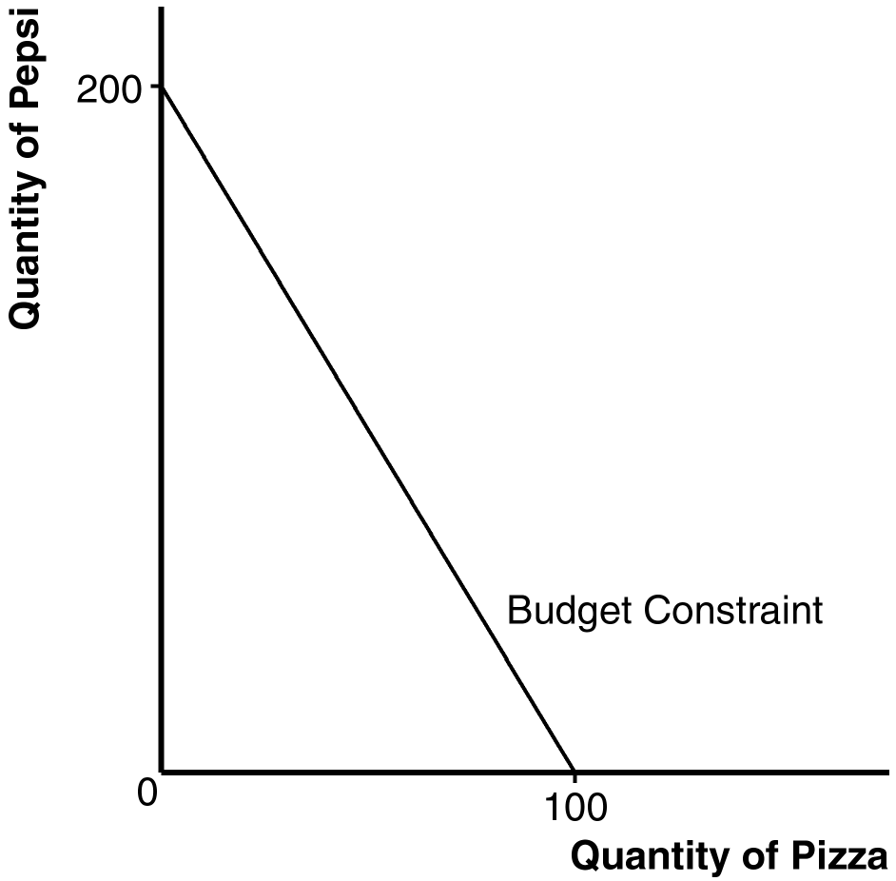
Figure 1

2. Figure 2 shows indifference curves between Pepsi and pizza. The four properties of these indifference curves are: (1) higher indifference curves are preferred to lower ones because consumers prefer more of a good to less of it; (2) indifference curves are downward sloping because if the quantity of one good is reduced, the quantity of the other good must increase for the consumer to be equally happy; (3) indifference curves do not cross because if they did, the assumption that more is preferred to less would be violated; and (4) indifference curves are bowed inward because people are more willing to trade away goods that they have in abundance and less willing to trade away goods of which they have little.

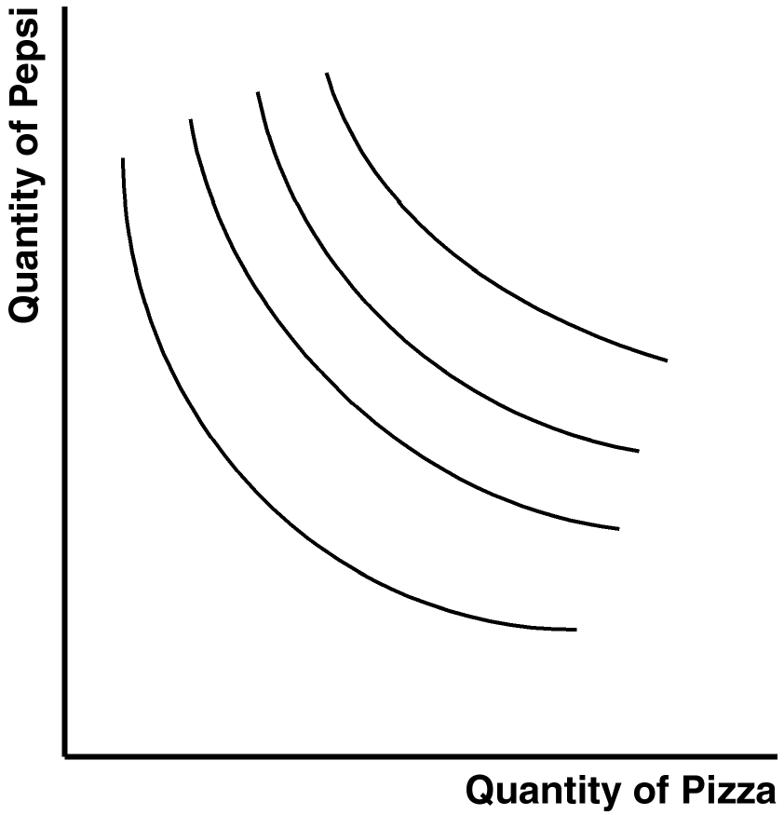

Figure 2

3. Figure 3 shows the budget constraint (BC₁) and two indifference curves. The consumer is initially at point A, where the budget constraint is tangent to an indifference curve. The increase in the price of pizza shifts the budget constraint to BC₂, and the consumer moves to point C where the new budget constraint is tangent to a lower indifference curve. To break this move down into income and substitution effects requires drawing the dashed budget line shown, which is parallel to the new budget constraint and tangent to the original indifference curve at point B. The movement from A to B represents the substitution effect, while the movement from B to C represents the income effect.

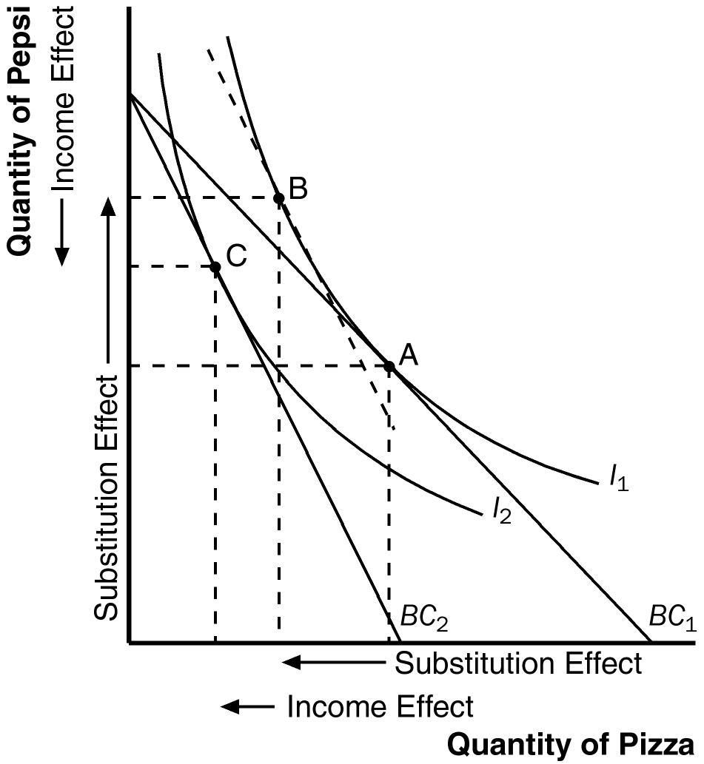

Figure 3

4. An increase in the wage can potentially decrease the amount that a person wants to work because a higher wage has an income effect that increases both leisure and consumption and a substitution effect that increases consumption and decreases leisure. Because less leisure means more work, a person will work more only if the substitution effect outweighs the income effect.

Questions for Review

1. Figure 4 shows the consumer's budget constraint. The intercept on the horizontal axis shows how much cheese the consumer could buy if she bought only cheese; with income of $3,000 and the price of cheese $6 a pound, she could buy 500 pounds of cheese. The intercept on the vertical axis shows how much wine the consumer could buy if she bought only wine; with income of $3,000 and the price of wine $3 a glass, she could buy 1,000 glasses of wine. With cheese on the horizontal axis and wine on the vertical axis, the budget constraint has a slope of -1,000/500 = -2.

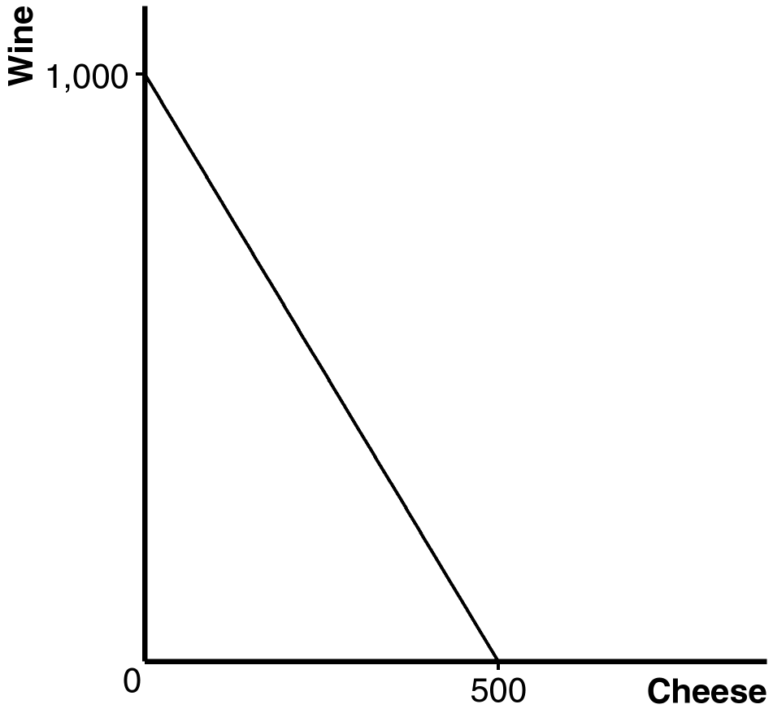

Figure 4

2. Figure 5 shows a consumer's indifference curves for wine and cheese. Four properties of these indifference curves are: (1) higher indifference curves are preferred to lower ones because more is preferred to less; (2) indifference curves are downward sloping because if the quantity of wine is reduced, the quantity of cheese must increase for the consumer to be equally happy; (3) indifference curves do not cross because a consumer prefers more to less; and (4) indifference curves are bowed inward because a consumer is more willing to trade away wine if she has a lot of it and less willing to trade away wine if she has little of it.

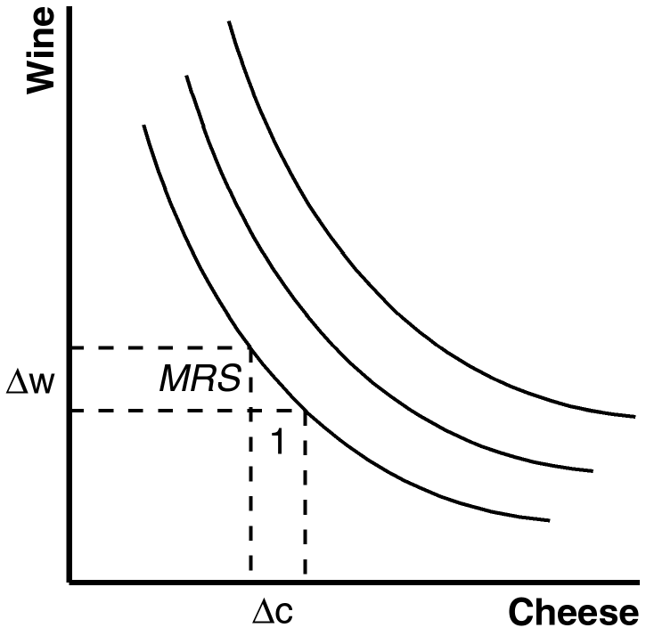

Figure 5

3. In Figure 5, the marginal rate of substitution (MRS) of one point on an indifference curve is shown. The marginal rate of substitution shows the amount of wine the consumer would be willing to give up to get one more pound of cheese.

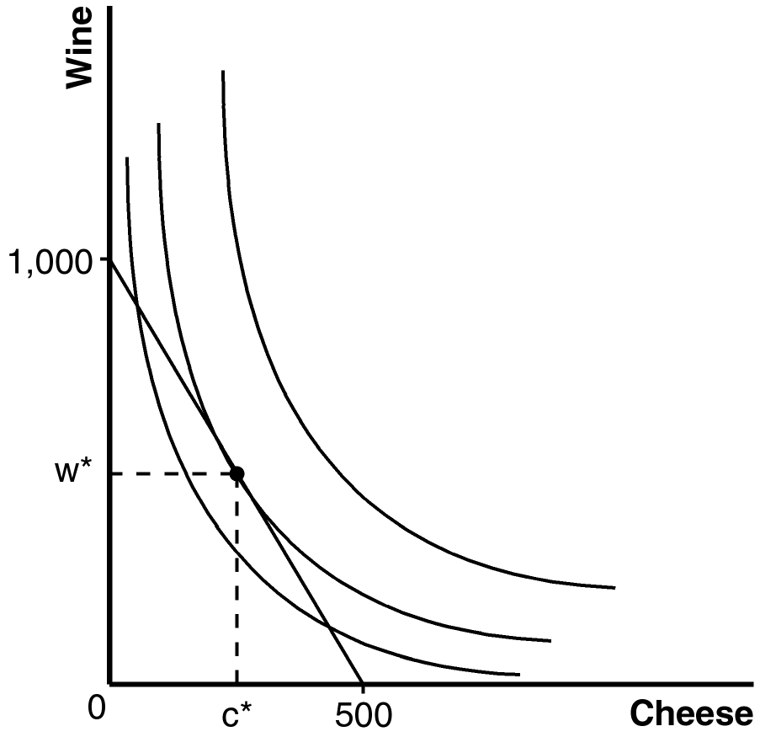

Figure 6

4. Figure 6 shows the consumer's budget constraint and indifference curves for wine and cheese. The consumer's optimum consumption choice is shown as w* and c*. Because the marginal rate of substitution equals the relative price of the two goods at the optimum, the marginal rate of substitution is $6/$3 = 2.

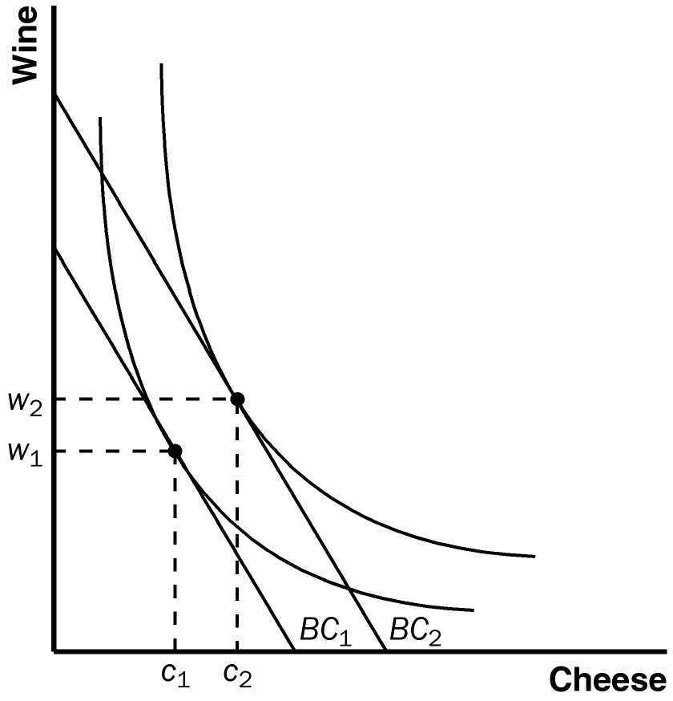
Figure 7

5. Figure 7 shows the effect of an increase in income. The rise in income shifts the budget constraint out from BC₁ to BC₂. If both wine and cheese are normal goods, consumption of both increases. If cheese is an inferior good, the increase in income causes the consumption of cheese to decline, as shown in Figure 8.

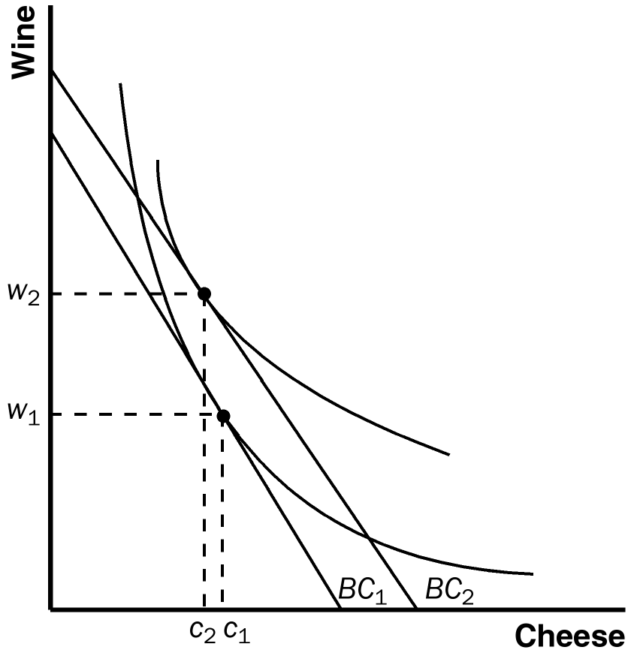

Figure 8

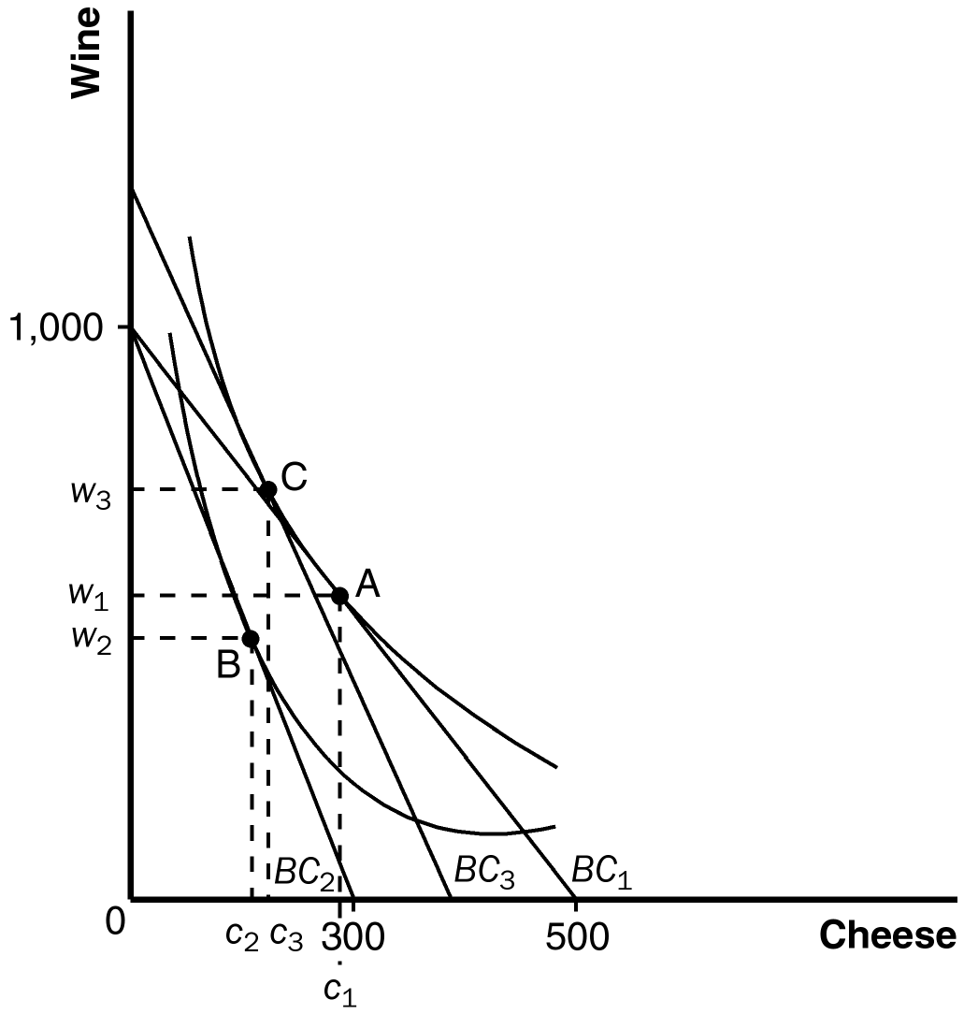

Figure 9

6. A rise in the price of cheese from $6 to $10 a pound makes the horizontal intercept of the budget line decline from 500 to 300, as shown in Figure 9. The consumer's budget constraint shifts from BC₁ to BC₂ and her optimal choice changes from point A (c₁ cheese, w₁ wine) to point B (c₂ cheese, w₂ wine). To decompose this change into income and substitution effects, we draw in budget constraint BC₃, which is parallel to BC₂ but tangent to the consumer's initial indifference curve at point C. The movement from point A to C represents the substitution effect. Because cheese became more expensive, the consumer substitutes wine for cheese as she moves from point A to C. The movement from point C to B represents an income effect. The rise in the price of cheese results in an effective decline in income.

7. An increase in the price of cheese could induce a consumer to buy more cheese if cheese is a Giffen good. In that case, the income effect of the rise in the price of cheese outweighs the substitution effect and induces the consumer to buy more cheese because cheese is an inferior good.

Quick Check Multiple Choice

1. d

2. b

3. b

4. c

5. c

6. d

Problems and Applications

1. a. Figure 10 shows the effect of the frost on Jennifer's budget constraint. Because the price of coffee rises, her budget constraint rotates from BC₁ to BC₂.

b. If the substitution effect outweighs the income effect for croissants, Jennifer buys more croissants and less coffee, as shown in Figure 10. She moves from point A to point B.
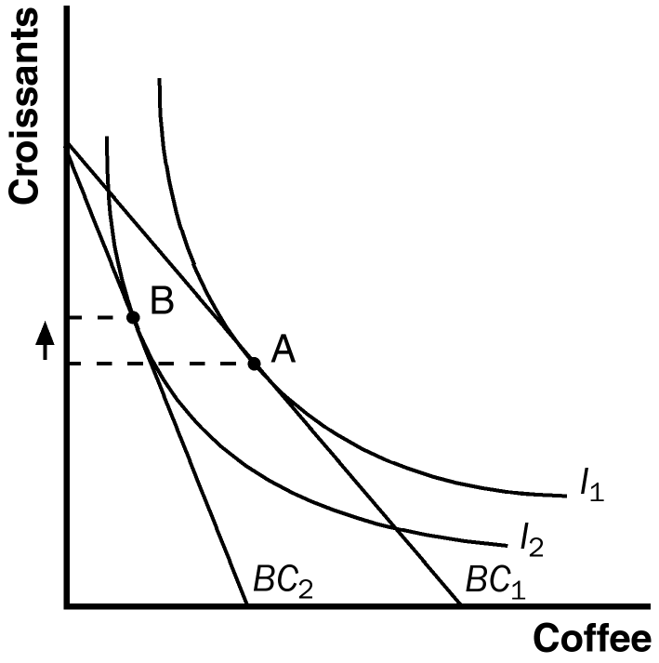
Figure 10

c. If the income effect outweighs the substitution effect for croissants, Jennifer buys fewer croissants and less coffee, moving from point A to point B in Figure 11.

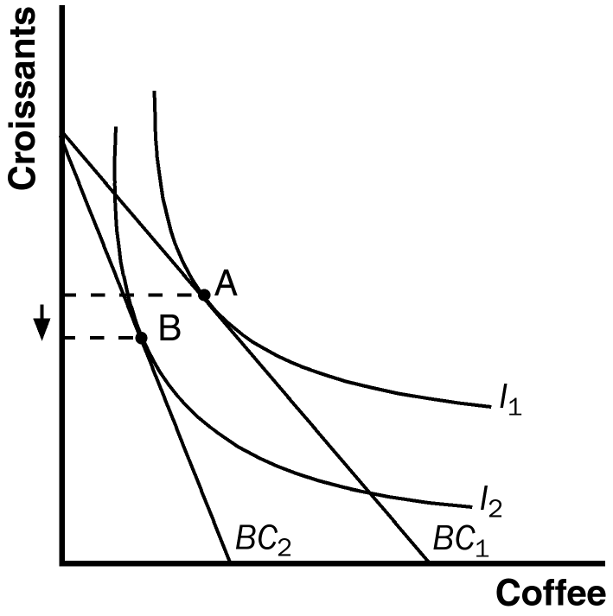
Figure 11

2. a. Skis and ski bindings are complements. Coke and Pepsi are substitutes.

b. Indifference curves between Coke and Pepsi are fairly straight, because there is little to distinguish them, so they are nearly perfect substitutes. Indifference curves between skis and ski bindings are very bowed, because they are complements.

c. A consumer will respond more to a change in the relative price of Coke and Pepsi, possibly switching completely from one to the other if the price changes.

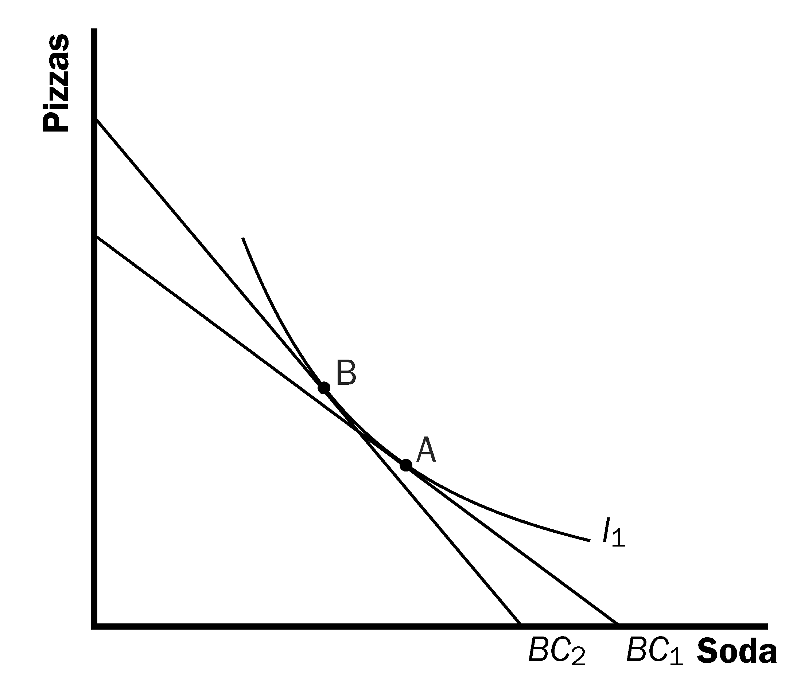

Figure 12

3. a. Figure 12 shows the effects of these price changes. If you are equally happy, you will remain on the same indifference curve. However, both the increase in the price of soda and the decline in the price of pizza make the budget constraint steeper.

b. You will consume less soda and more pizza. Since you remain equally happy, there is only the substitution effect to consider.

c. You can no longer afford your initial bundle. It lies outside of your new budget constraint.

4. a. Cheese and crackers cannot both be inferior goods, because if Mario's income rises he must consume more of something.

b. If the price of cheese falls, the substitution effect means Mario will consume more cheese and fewer crackers. The income effect means Mario will consume more cheese (because cheese is a normal good) and fewer crackers (because crackers are an inferior good). So, both effects lead Mario to consume more cheese and fewer crackers.

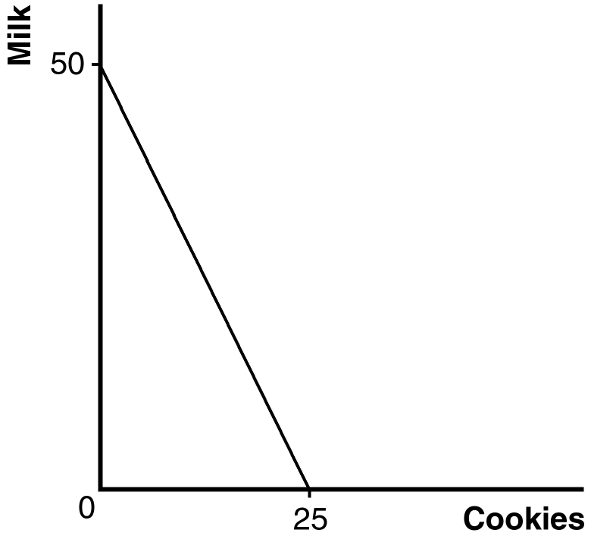

Figure 13

5. a. Figure 13 shows Jim's budget constraint. The vertical intercept is 50 quarts of milk, because if Jim spent all his money on milk he would buy $100/$2 = 50 quarts of it. The horizontal intercept is 25 dozen cookies, because if Jim spent all his money on cookies he would buy $100/$4 = 25 dozen cookies.

b. If Jim's salary rises by 10 percent to $110 and the prices of milk and cookies rise by 10 percent to $2.20 and $4.40, Jim's budget constraint would be unchanged. Note that $110/$2.20 = 50 and $110/$4.40 = 25, so the intercepts of the new budget constraint would be the same as the old budget constraint. Because the budget constraint is unchanged, Jim's optimal consumption is unchanged.

6. a. This statement is true. All Giffen goods are inferior goods. It is impossible to have a Giffen good that is a normal good.

b. This statement is false. A Giffen good is a special case of an inferior good for which the income effect outweighs the substitution effect.

7. a. Figure 14 shows the student’s budget constraint. If she spends equal amounts on both goods, she will purchase 5 meals in the dining hall and 20 packages of Cup O’ Soup represented by point A.

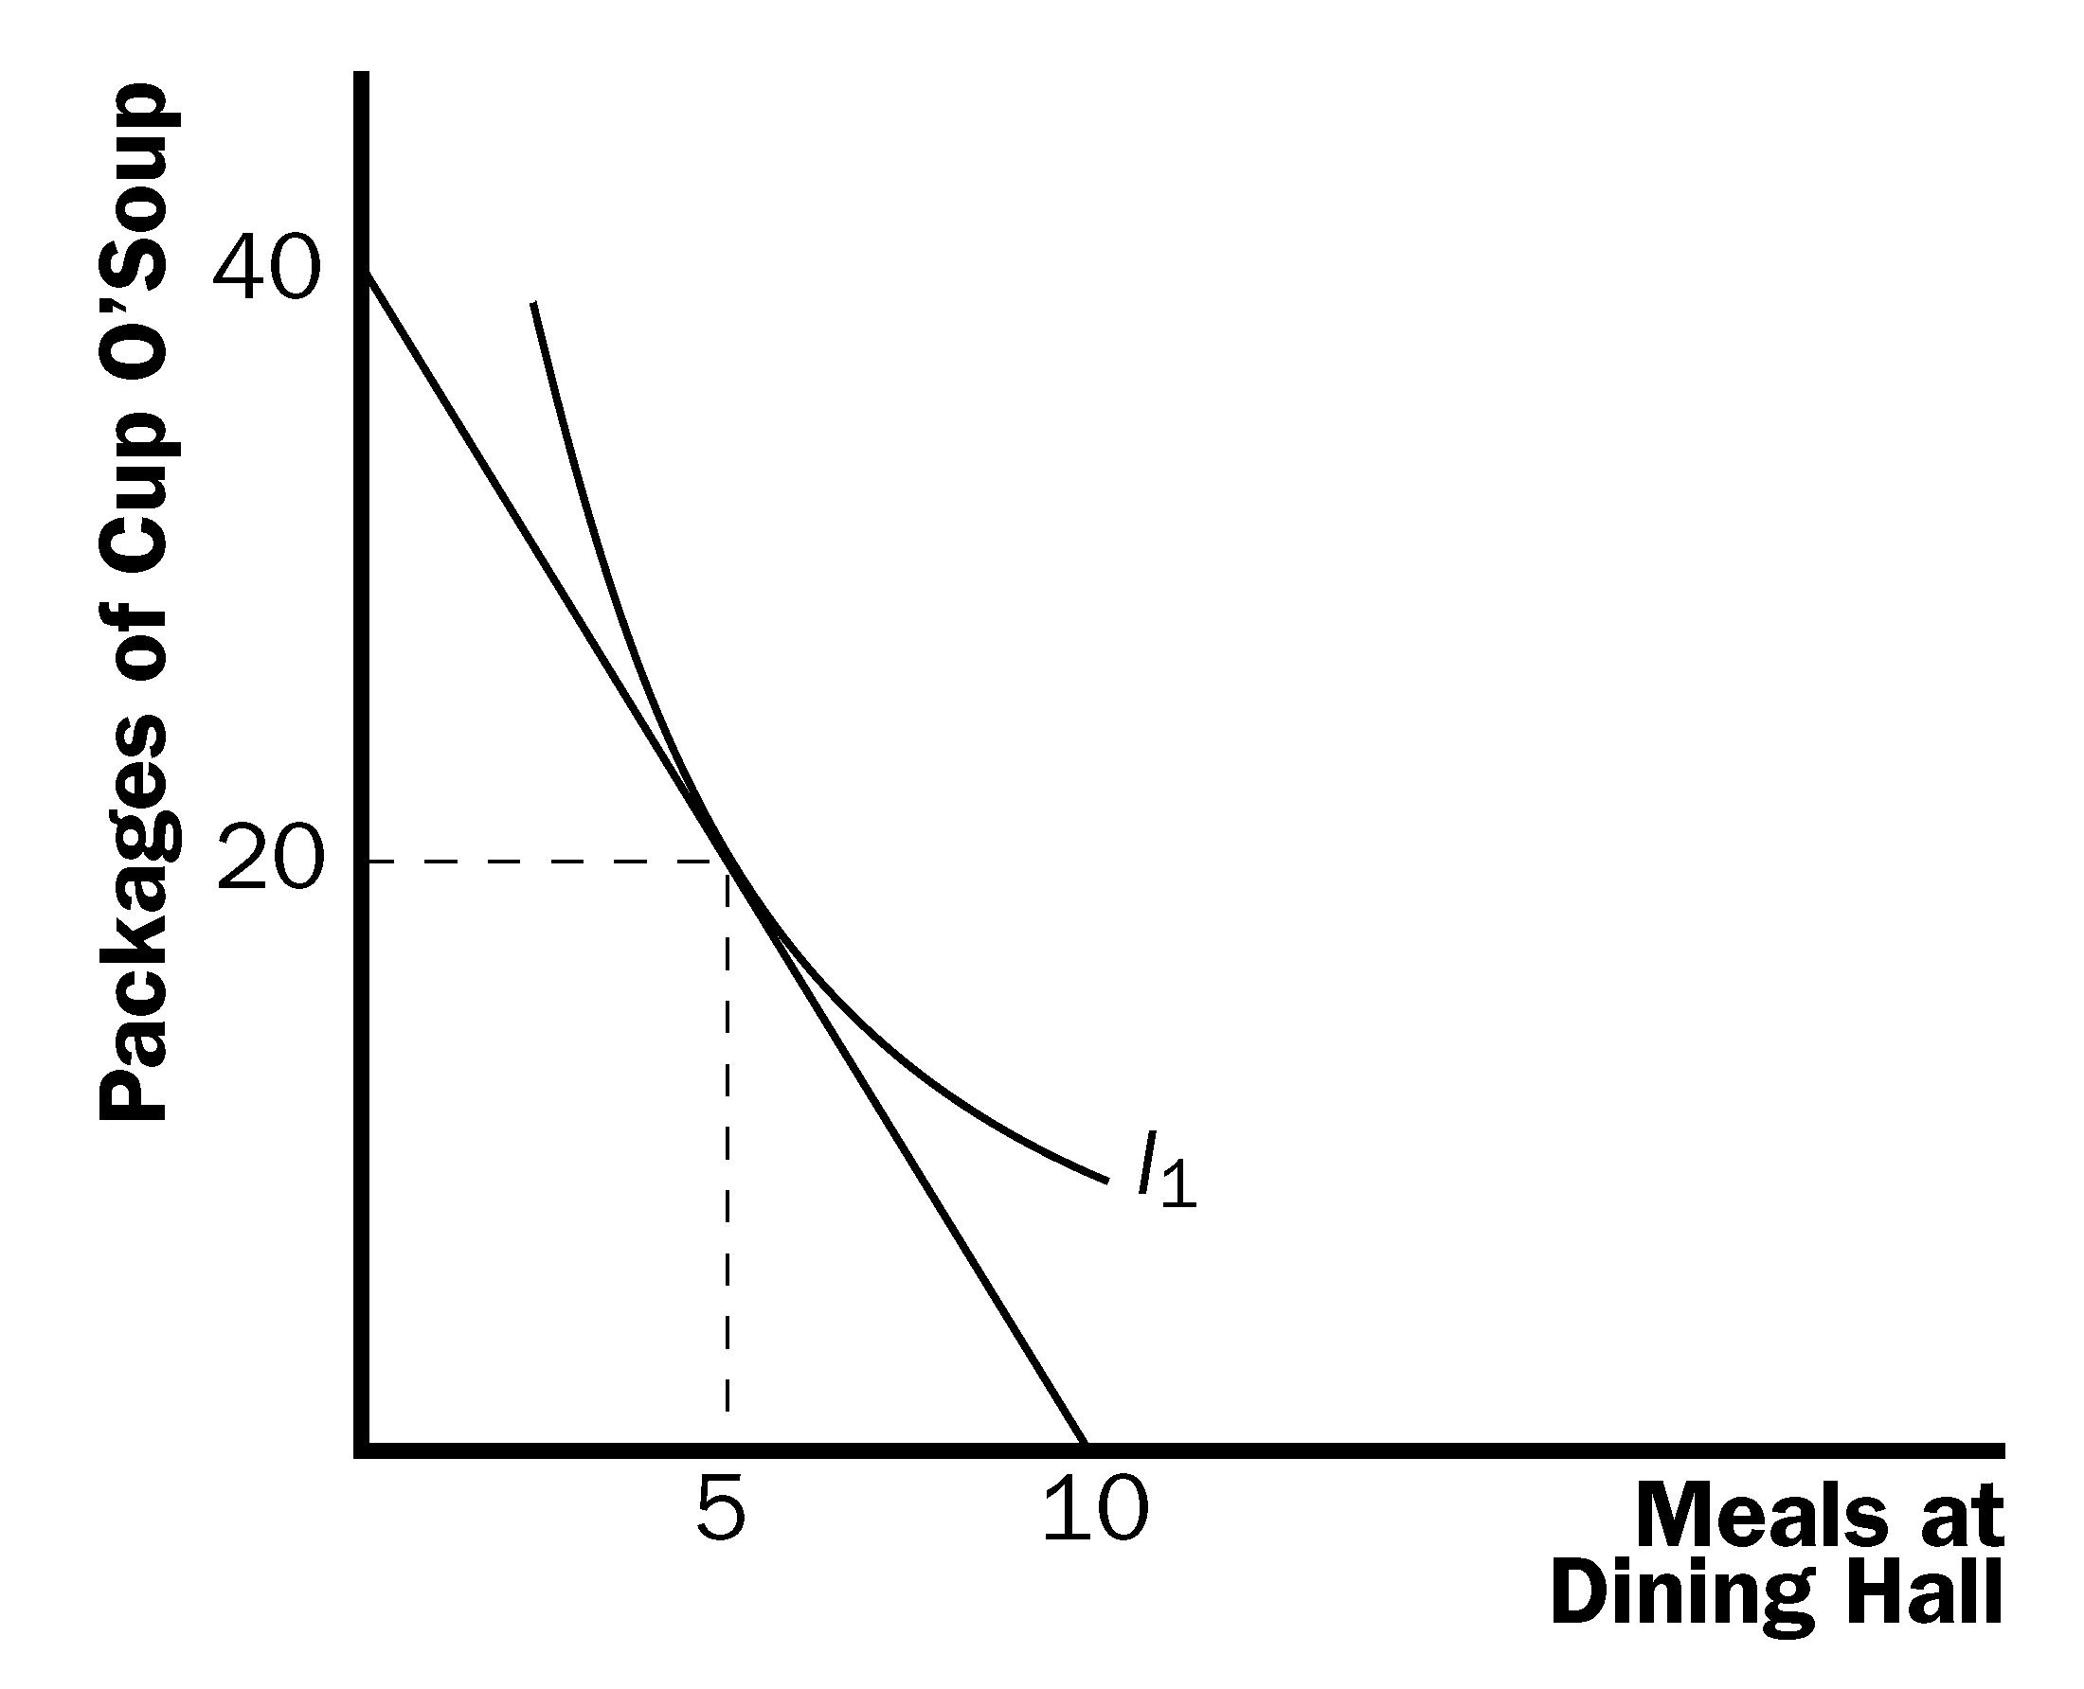
A

Figure 14

b. If the price of Cup O’ Soup rises to $2, the student’s budget constraint will get flatter (see Figure 15). She will now spend $18 on dining hall meals (purchasing 3) and $42 on Cup O’ Soup (purchasing 21 packages).

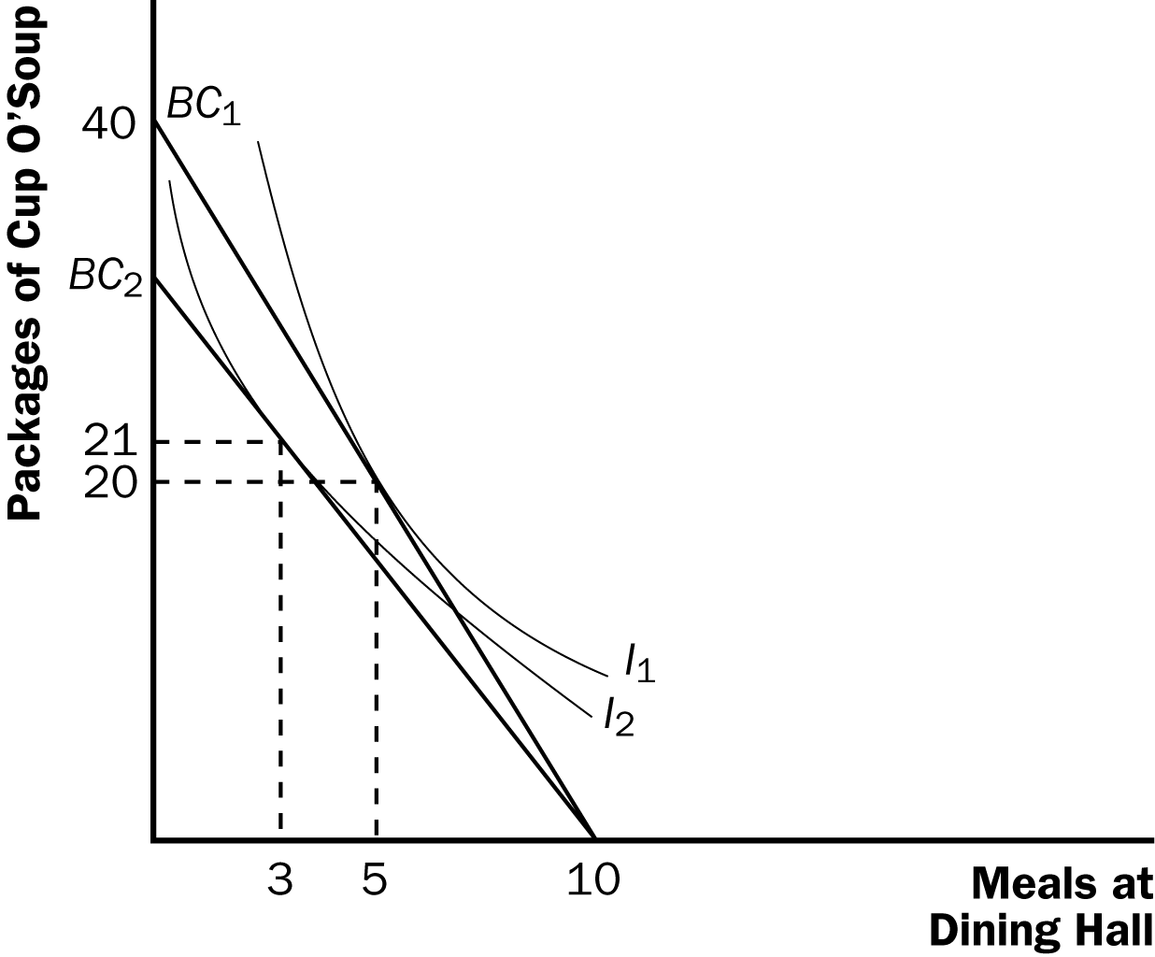

Figure 15

c. As the price of Cup O’ Soup rises, the student purchased more. This means that Cup O’ Soup is an inferior good for which the income effect outweighs the substitution effect.

d. Figure 16 shows the student’s demand for Cup O’ Soup. It is upward sloping, indicating that Cup O’ Soup is a Giffen good.

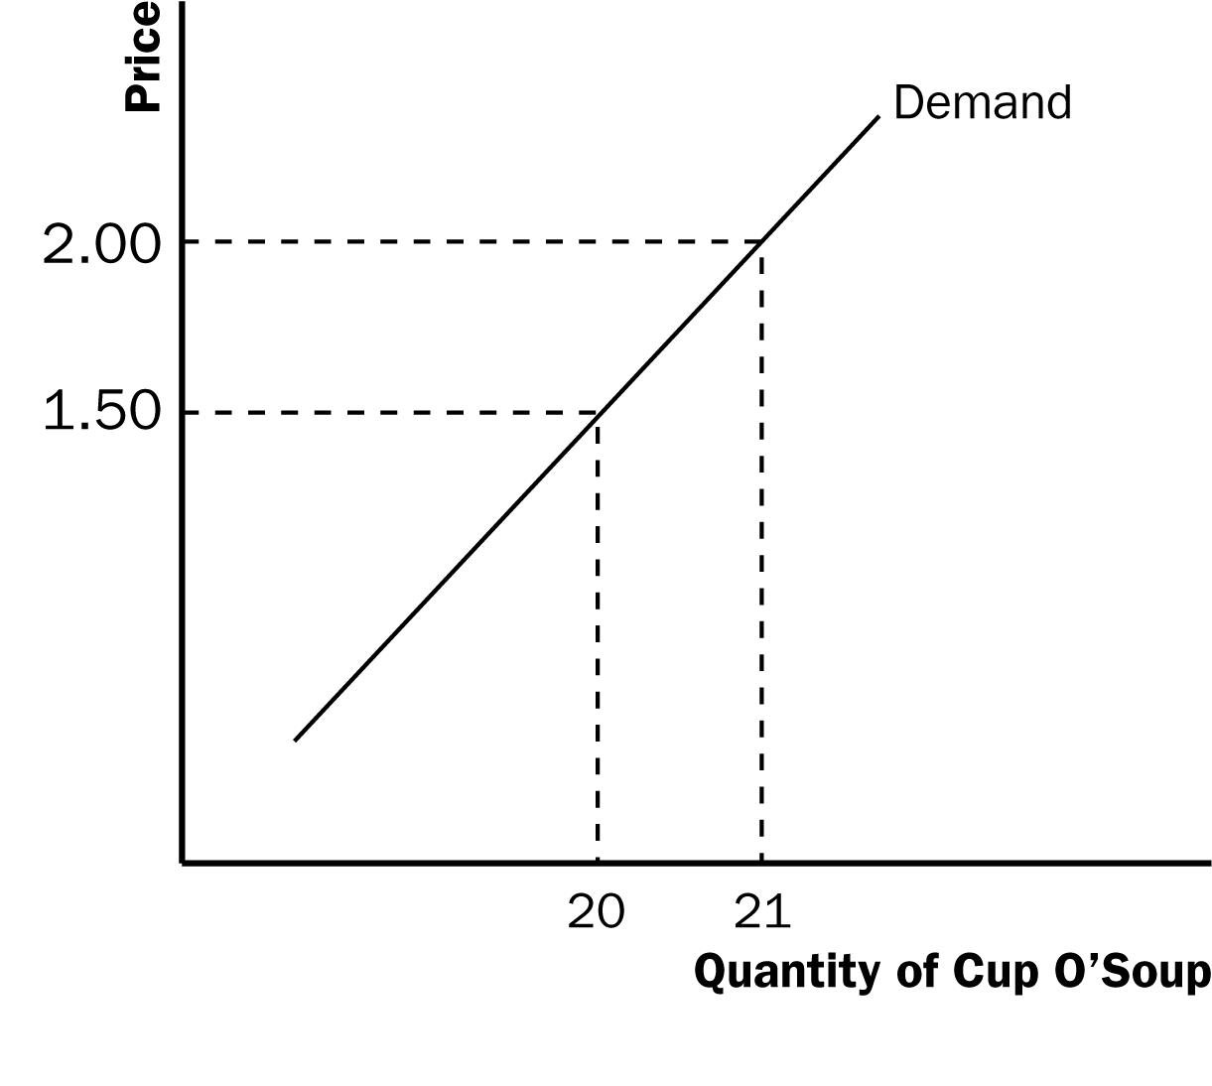

Figure 16

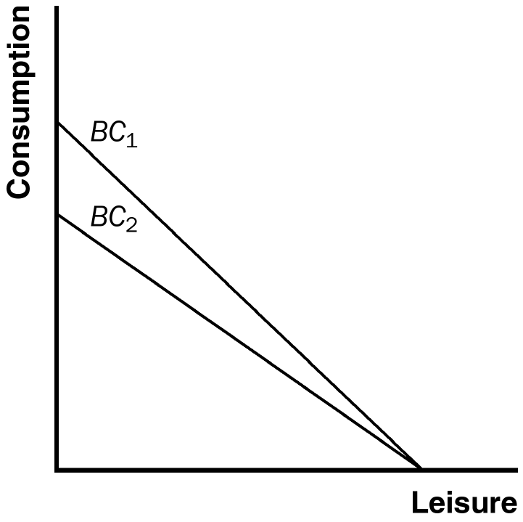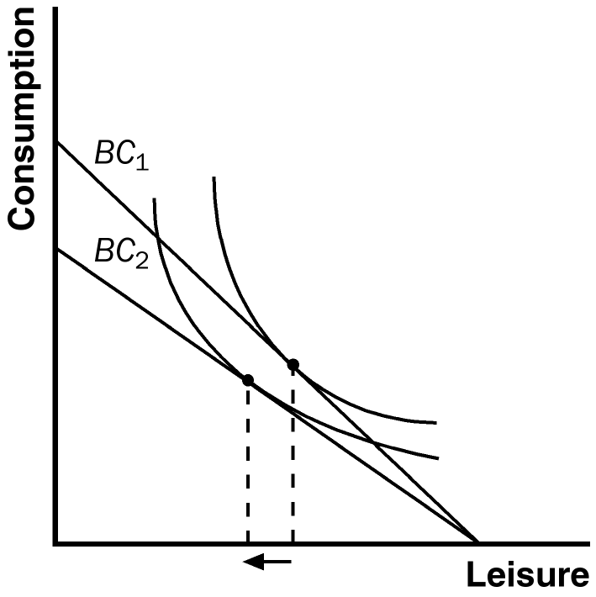

Figure 17 Figure 18

8. a. Budget constraint BC₁ in Figure 17 shows the budget constraint if you pay no taxes. Budget constraint BC₂ shows the budget constraint with a 15 percent tax.

b. Figure 18 shows indifference curves for which a person will work more as a result of the tax because the income effect (less leisure) outweighs the substitution effect (more leisure), so there is less leisure overall. Figure 19 shows indifference curves for which a person will work fewer hours as a result of the tax because the income effect (less leisure) is smaller than the substitution effect (more leisure), so there is more leisure overall. Figure 20 shows indifference curves for which a person will work the same number of hours after the tax because the income effect (less leisure) equals the substitution effect (more leisure), so there is the same amount of leisure overall.

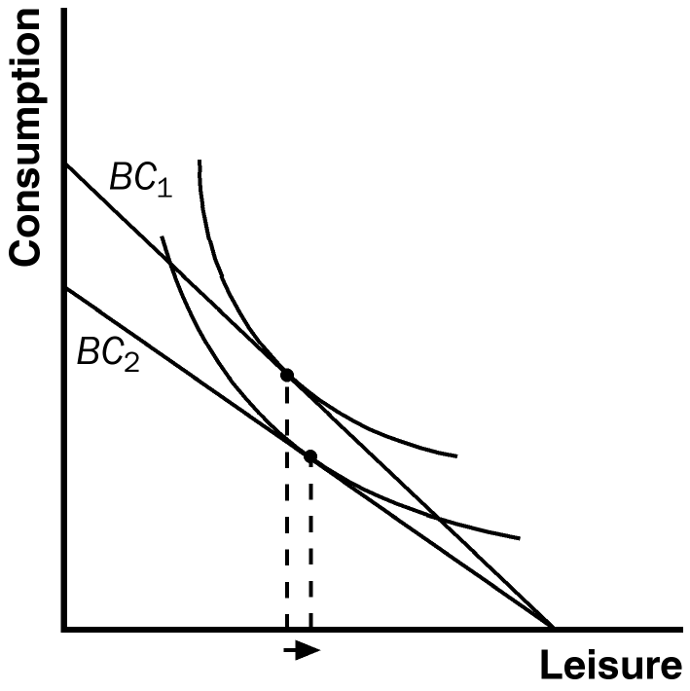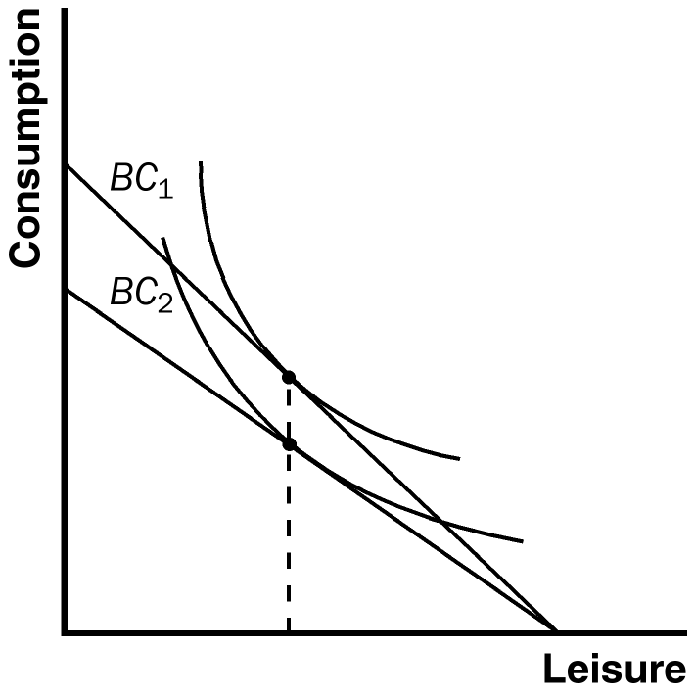

Figure 19 Figure 20

9. Figure 21 shows Sarah's budget constraints and indifference curves if she earns $6 (BC₁), $8 (BC₂), and $10 (BC₃) per hour. At a wage of $6 per hour, she works 100 – L₆ hours; at a wage of $8 per hour, she works 100 – L₈ hours; and at a wage of $10 per hour, she works 100 – L₁₀ hours. Because the labor supply curve is upward sloping when the wage is between $6 and $8 per hour, L₆ > L₈; because the labor supply curve is backward sloping when the wage is between $8 and $10 per hour, L₁₀ > L₈.

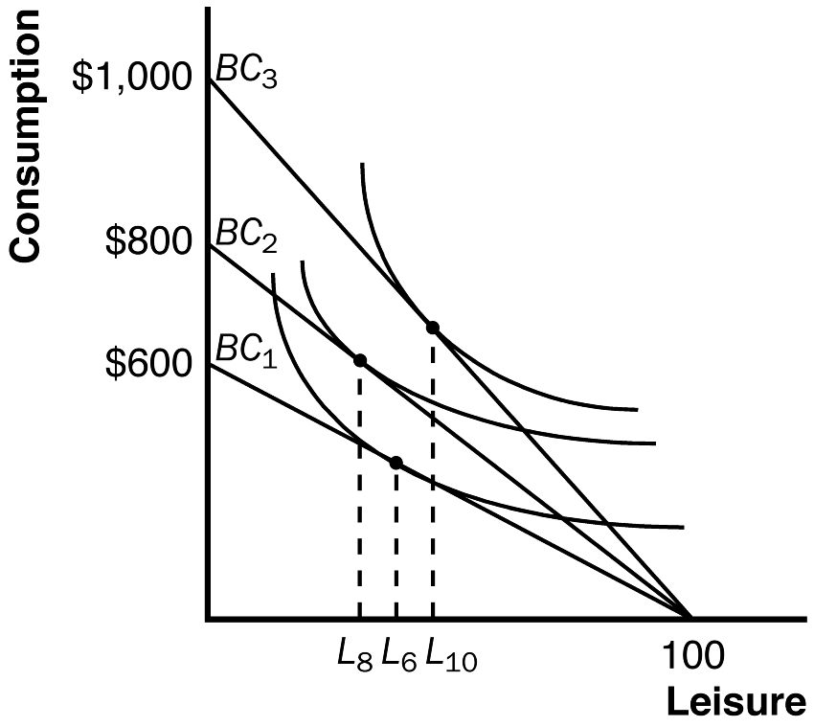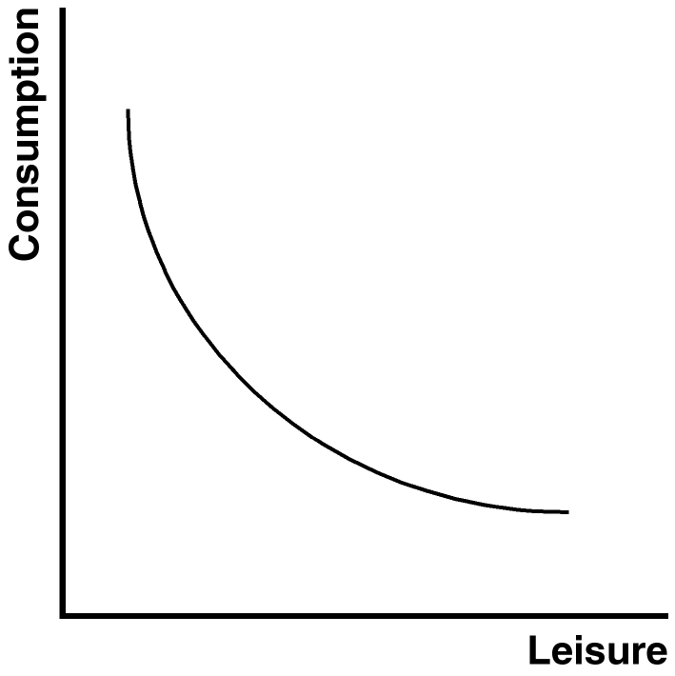

Figure 21 Figure 22

10. Figure 22 shows the indifference curve between leisure and consumption that determines how much a person works. An increase in the wage leads to both an income effect and a substitution effect. The higher wage makes the budget constraint steeper, so the substitution effect increases consumption and reduces leisure. But the higher wage has an income effect that increases both consumption and leisure if both are normal goods. The only way that consumption could decrease when the wage increased would be if consumption is an inferior good and if the negative income effect outweighs the positive substitution effect. This could happen for a person who really placed an exceptionally high value on leisure.

11. a. Figure 23 shows the budget constraint. The initial budget line is shown as BL₁. If all hours are spent raising children, 10 children can be raised. If all hours are spent working, $2,000,000 can be earned for consumption. The individual maximizes utility by choosing K₁ children and a consumption level of C₁.

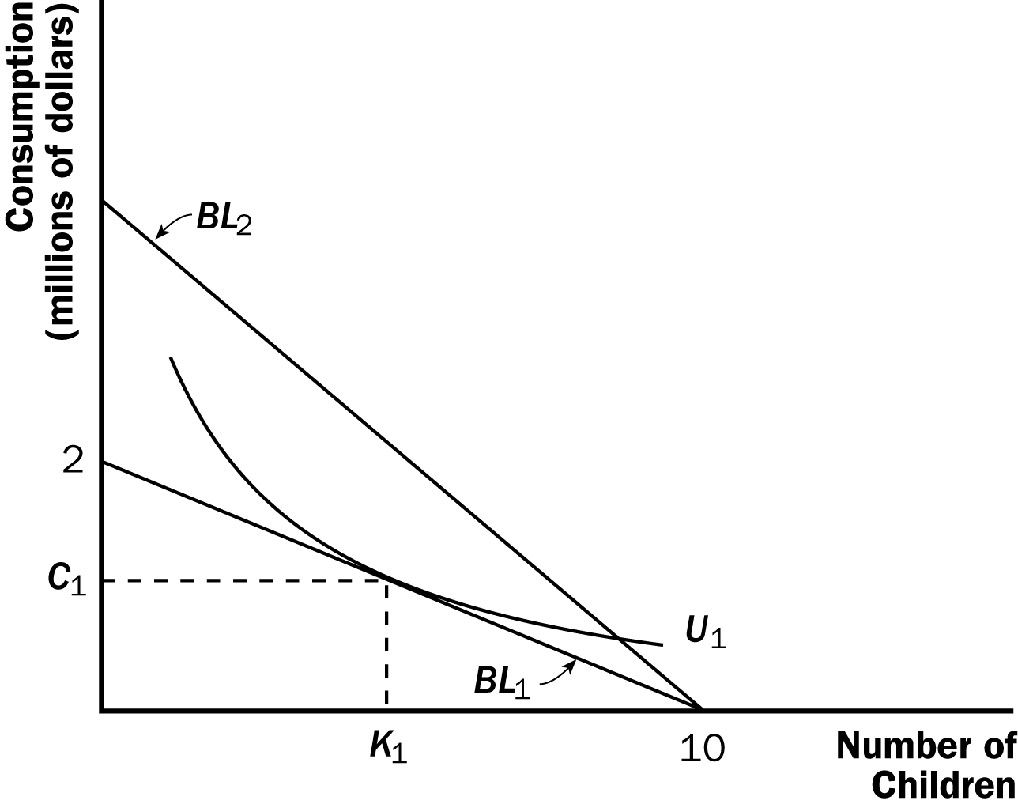

Figure 23

b. If the wage rises, the budget line rotates to BL₂ in Figure 23. The budget line is now steeper indicating the higher opportunity cost of raising a child. The substitution of this increase in the wage will mean a rise in consumption and a decline in the number of children. Assuming that both children and consumption are normal goods, the income effect of the increased wage will mean a rise in both children and consumption. The full effect on consumption is positive, but the end effect on children depends on the relative sizes of the income and substitution effects.

c. If the number of children declines as incomes rise, the substitution effect must outweigh the income effect.

12. If consumers do not buy less of a good when their incomes rise, the good in question must be a normal good. For a normal good, the income and substitution effects both imply that the consumer will buy less if the price rises.

13. Utility is maximized when the marginal utility per dollar spent is equal across goods. Claire and Alex are both purchasing the utility-maximizing combination of apples and pears. Phil and Haley each get greater utility per dollar spent on apples than on pears. Therefore, they should purchase more apples and fewer pears. On the other hand, Luke gets higher utility per dollar spent on pears than on apples. He should reallocate his budget as well, increasing his purchases of pears and reducing his purchases of apples.

